12th chemistry
CHAPTERS: BIOMOLECULES & HALOALKANE &HALOARENES
Que1. Classify the following into monosaccharides and disaccharides.
Ribose, 2-deoxyribose, maltose, galactose, fructose and lactose.
Que2. What are monosaccharides?
Que3. Define the following as related to proteins (i) Peptide linkage (ii) Primary structure (iii) Denaturation.
Que4. What is the basic structural difference between starch and cellulose?
Que5. What happens when D-glucose is treated with the following reagents? (i) HI (ii) Bromine water (iii) HNO3
Que6. Enumerate the reactions of D-glucose which cannot be explained by its open chain structure.
Que7What are essential and non-essential amino acids? Give two examples of each type.
Que8.Define the following as related to proteins (i) Peptide linkage (ii) Primary structure (iii) Denaturation.
Que9.What are the common types of secondary structure of proteins?
Que10.What type of bonding helps in stabilising the a-helix structure of proteins?
Que11Differentiate between globular and fibrous proteins.
Que12.How do you explain the amphoteric behaviour of amino acids?
Que13.What are enzymes? What is the effect of denaturation on the structure of proteins?
Que14.How are vitamins classified? Name the vitamin responsible for the coagulation of blood.
Que15.Why are vitamin A and vitamin C essential to us? Give their important sources.
Que16. What are nucleic acids? Mention their two important functions.
Que17.What is the difference between a nucleoside and a nucleotide?
Que18.The two strands in DNA are not identical but are complementary. Explain.
Que19.Write the important structural and functional differences between DNA and RNA.
Que20. What are the different types of RNA found in the cell?
Que21. Why is sulphuric acid not used during the reaction of alcohols with KI?
Que22.Write structures of different dihalogen derivatives of propane.
Que23.Among the isomeric alkanes of molecular formula C5H12, identify the one that on photochemical chlorination yields (i) A single monochloride. (ii) Three isomeric monochlorides. (iii) Four isomeric monochlorides.
Que24. Draw the structures of major monohalo products in each of the following reactions:
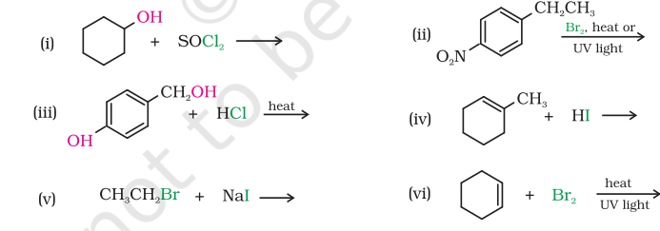
Que25. Can you think why does NO2 group show its effect only at ortho- and para- positions and not at meta- position?
Que26. Although chlorine is an electron withdrawing group, yet it is ortho-, para- directing in electrophilic aromatic substitution reactions. Why?
Que27. Which alkyl halide from the following pairs would you expect to react more rapidly by an SN 2 mechanism? Explain your answer.
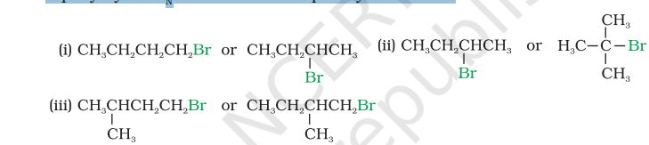
Que28. Explain why (i) the dipole moment of chlorobenzene is lower than that of cyclohexyl chloride? (ii) alkyl halides, though polar, are immiscible with water? (iii) Grignard reagents should be prepared under anhydrous conditions?
Que29. How the following conversions can be carried out?
- Propene to propan-1-ol
- Ethanol to but-1-yne
- 1-Bromopropane to 2-bromopropane
- Toluene to benzyl alcohol
- Benzene to 4-bromonitrobenzene
- Benzyl alcohol to 2-phenylethanoic acid
- Ethanol to propanenitrile
- Aniline to chlorobenzene
- 2-Chlorobutane to 3, 4-dimethylhexane
- 2-Methyl-1-propene to 2-chloro-2-methylpropane
- Ethyl chloride to propanoic acid
- But-1-ene to n-butyliodide
- 2-Chloropropane to 1-propanol
- Isopropyl alcohol to iodoform
- Chlorobenzene to p-nitrophenol
- 2-Bromopropane to 1-bromopropane
- Chloroethane to butane
- Benzene to diphenyl
- tert-Butyl bromide to isobutyl bromide
- Aniline to phenylisocyanide
Que30. What happens when
(i) n-butyl chloride is treated with alcoholic KOH,
(ii) bromobenzene is treated with Mg in the presence of dry ether,
(iii) chlorobenzene is subjected to hydrolysis,
(iv) ethyl chloride is treated with aqueous KOH,
(v) methyl bromide is treated with sodium in the presence of dry ether,
(vi) methyl chloride is treated with KCN?

